
CTNNB1 (G34V)
Catalog Number: CR-M26299
Gene Symbol: Beta-catenin, CTNNB, Catenin beta-1
Description: Anti-CTNNB1 (G34V) Mouse Monoclonal Antibody

Background: CTNNB1 protein is a dual function protein. It is a subunit of a complex of proteins
that from adherens junctions, which are important for the establishment and maintenance of
epithelial cell layers by regulating cell growth
and adhesion between adjacent cells. CTNNB1 protein also pulls double duty as an intracellular signal transducer in the Wnt signaling pathway. Mutations of CTNNB1 have been implicated in the pathogenesis of several cancers.
Immunogen: A synthetic peptide from the
internal region of CTNNB1 which includes the mutation of G34V, human origin.
Tested applications: ELISA, WB, IHC Recommended dilutions:
ELISA: 1:1000-1:2000
WB: 1:500-1:1000
IHC: 1:50-1:100
Concentration: 0.5 mg/ml
Host: Mouse
Clonality: Monoclonal
Purity: Purified from ascites
Format: Liquid Storage buffer:
Preservative: no
Constituents: PBS (without Mg2+ and Ca2+), pH 7.4, 150 mM NaCl, 50% glycerol
Species Reactivity: Recognizes G34V mutant, but not wild-type CTNNB1 of vertebrates.
Storage Conditions: Store at -20°C. Avoid freeze / thaw cycles.

Western blot:
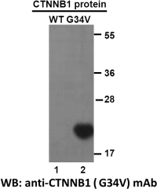

Western blot analysis of recombinant
CTNNB1 (G34V) and wildtype proteins.
Purified His-tagged CTNNB1 (G34V) protein
(lane2) and corresponding wild-type protein
(lane1) were blotted with anti-CTNNB1 (G34V) monoclonal antibody (Cat. #26299).

For research use only. Not for diagnostic or therapeutic applications.

Immunofluorescence:

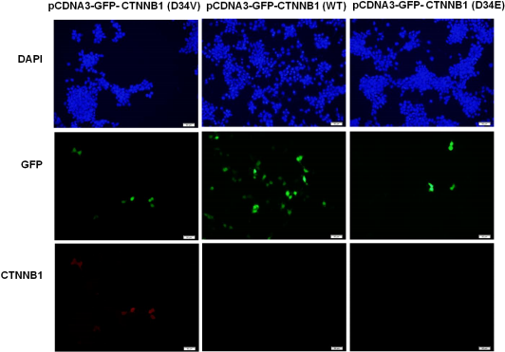
Immunofluorescence of cells expressing CTNNB1 proteins with anti-CTNNB1 (G34V) antibody.
HEK293T cells were transfected with pCDNA3-GFP-CTNNB1 (G34V) plasmid,
pCDNA3-GFP-CTNNB1 (WT) plasmid or pCDNA3-GFP-CTNNB1 (G34E) plasmid, then fixed and stained with anti-CTNNB1 (G34V) monoclonal antibody (Cat. #26299).

科博瑞（武汉）生物科技有限公司
TEL：027-87615885 15972062685
- mail：3636901710@qq.com
Web:www.coburybio.com

